**Tutorial – 3**

1. . Draw a real picture for class and object. Differentiate class and object in terms of diagram only. Perform following tasks.

Task 1: Create a class .

Task 2:Add few data members as private Task 3:

Add few methods as public to work on defined data members

Task 4: Create a Demo class with main method.

Task 5: Create at least two objects of a class defined in Task 1 into main method and call all methods using that object.

Task 6: Write comment for each important portion of code like data members’ declaration, methods, some important logic etc.

Task 7: Summarize above solution in your own few words to visualize the solution to the end user

**Code:**

//20SOECE11113

using System;

namespace Tutorial_3

{

class A1

{

public void get_data()

{

Console.Write("Enter Length : ");

int l = Convert.ToInt32(Console.ReadLine()); Console.Write("Enter breadth : ");

int b = Convert.ToInt32(Console.ReadLine()); int area = l * b;

Console.Write("Area of Rectangle : {0}", area);

}

}

class Program

{

public static void Main(string[] args)

{

A1 obj1 = new A1(); obj1.get_data();

}

}

}

**Output:** 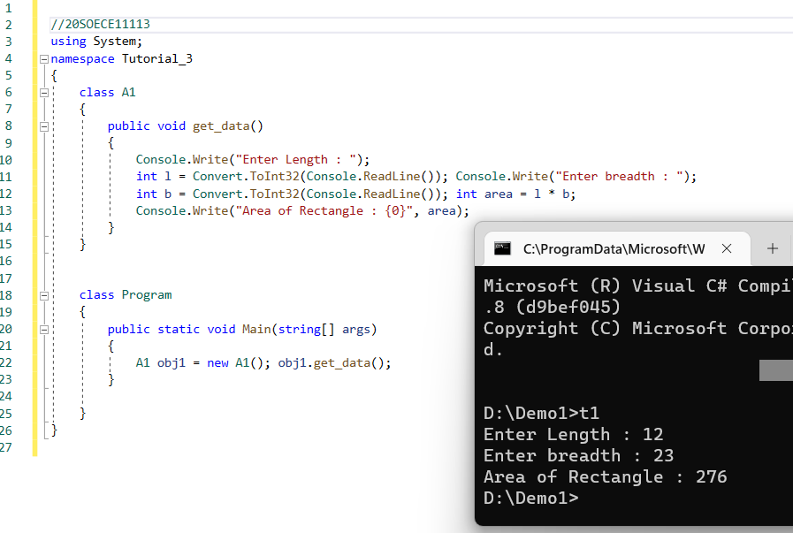

1. **Define a class Clock with three private integer data members hour, min and sec. Define a no argument constructor to initialize time value to 12:00:00. Define a three-argument constructor to initialize the time. Define a method to**

# Increment time to next second.

* 1. Display the time value.
  2. Return the hour (*int getHour()*)
  3. Return the minute (*int getMinute()*)
  4. Return the seconds (*int getSeconds()*).

**Code:**

using System;

using System.Collections.Generic;

using System.Linq;

using System.Text;

using System.Threading.Tasks;

namespace Tutorial3

{

class Clock

{

private int hour, min, sec; public Clock()

{

this.hour = 22;

this.min = 55;

this.sec = 58;

}

public Clock(int h, int m, int s)

{

this.hour = h; this.min = m; this.sec = s;

}

public void inc()

{

sec++;

Console.WriteLine("New time is : " + hour + ":" + min + ":" + sec);

}

public void display()

{

Console.WriteLine("Time is : " + hour + ":" + min + ":" + sec);

}

public int gethour()

{

return hour;

}

public int getmin()

{

return min;

}

public int getsec()

{

return sec;

}

}

class program

{

public static void Main(string[] args)

{

Clock obj1 = new Clock(11, 10, 01); obj1.display();

obj1.inc();

}

}

}

**Output:**

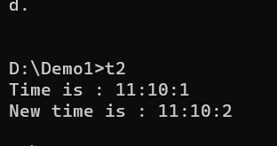

3.Define a Student class with appropriate data members, property, constructors, method etc. Define another class called TestStudent within the same .cs file. Also create an object of student class and demonstrate the use of student class.

**Code:**

using System;

class Student

{

public int rollNumber; public string name;

}

class TestStudent

{

static void Main(string[] args)

{

Student s = new Student();

s.rollNumber = 43;

s.name = "Dheeraj Prajapati";

Console.WriteLine("\nRoll no : {0}", s.rollNumber);

Console.WriteLine("Name:{0}", s.name);

Console.ReadLine();

}

}

**Output:**

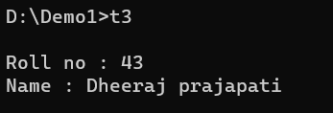

**4.Use above program classes and create objects for 5 students and demonstrate the use student class.**

using System; class Student

{

public int rollNumber; public string name;

}

class Test

{

static void Main(string[] args)

{

Student s = new Student(); s.rollNumber = 1;

s.name = "Ashok";

Console.WriteLine("\nRoll no : {0}", s.rollNumber); Console.WriteLine("Name : {0}", s.name);

Student s1 = new Student(); s1.rollNumber = 2;

s1.name = "Jeet";

Console.WriteLine("Roll no : {0}", s1.rollNumber); Console.WriteLine("Name : {0}", s1.name);

Student s2 = new Student(); s2.rollNumber = 3;

s2.name = "Deven";

Console.WriteLine("Roll no : {0}", s2.rollNumber); Console.WriteLine("Name : {0}", s2.name);

Student s4 = new Student(); s4.rollNumber = 4;

s4.name = "Misti";

Console.WriteLine("Roll no : {0}", s4.rollNumber); Console.WriteLine("Name : {0}", s4.name);

Student s5 = new Student(); s5.rollNumber = 5;

s5.name = "Sapana";

Console.WriteLine("Roll no : {0}", s5.rollNumber); Console.WriteLine("Name : {0}", s5.name); Console.ReadLine();

}

}

**Output:**

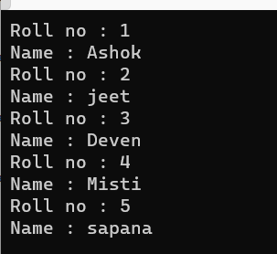

**5.Rearrange the given code to get the desired output.**

using System; namespace tt3_5

{

class Product

{

String pname, mname; int pcode;

public Product(int pcd, String pnm, String mnm)

{

mname = mnm; pcode = pcd; pname = pnm;

}

public void Display()

{

Console.Write("\nProduct Code:= " + pcode); Console.Write("\nProduct Name:= " + pname); Console.Write("\nManufacturer Name:= " + mname);

}

}

public class TestProduct

{

public static void Main(string[] args)

{

int n = args.Length; if (n < 3)

{

Console.WriteLine("Syntax Error\n"); Console.WriteLine("Must Have THREE Arguments\n");

Console.WriteLine("Please, Write as [csc TestProduct ProductCode ProductName Manufacturer] \n");

}

else

{

int pcd = Convert.ToInt32(args[0]); String pnm = args[1];

String mnm = args[2];

Product p = new Product(pcd, pnm, mnm); p.Display();

Console.ReadLine();

}

}

}

}

**Output:**

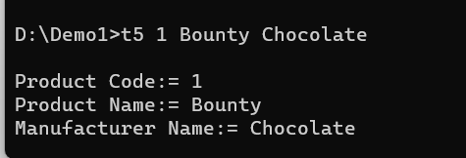

6.Complete the following code that will generate the given output:

using System;

namespace Tutorial3

{

class Line

{

private double length; // Length of a line public Line()

{

Console.Write("\nObject is being created, Length : "); length = Convert.ToDouble(Console.ReadLine());

}

public void setLength(double len)

{

length = len;

}

public double getLength()

{

return length;

}

}

class TestLine

{

static void Main(string[] args)

{

Line line = new Line();

Console.WriteLine("Length of line : {0}", line.getLength()); line.setLength(6);

Console.WriteLine("Length of line : {0}", line.getLength()); Console.ReadLine();

}

}

}

**Output:**

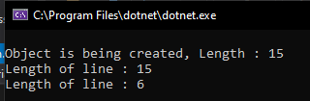

**7.Define Enrollment No and Name properties for the student class and demonstrate use of these properties along with required data members, methods and constructors.**

**CODE;**

using System;

class student

{

String name, enrol; public student()

{

Console.Write("\nEnter Name : ");

name = Console.ReadLine();

Console.Write("Enter Enrollment : ");

enrol = Console.ReadLine();

}

public void Display()

{

Console.Write("Your Name is : {0}", name);

Console.WriteLine("\nYour Enrollment is : {0}", enrol);

}

}

class program

{

public static void Main(string[] args)

{

student obj1 = new student();

obj1.Display();

Console.ReadLine();

}

}

**Output:**

